Team Deliverable #2:
Project 2

Edmonds Community College
CIS 234: Systems Design and Development
Spring Quarter 2012
Travis Cooper (Information/ Data Model)
Tim Wilkie (User Navigation Design (Story Board))
Nick Williams (Inputs, Outputs)
George Miaski (Arch & Design, Procedures)
Cynde Hall (Memo, Table of Contents, Intro, Conclusion)
Chanya Kit (Interface Design & Coding, Appendices)

Superior I.T. System Solutions

Superior I.T. Systems Solutions
206-797-8367
512 Terry Avenue N., Seattle, WA 98102 superiorsolutions@gmail.com

DATE: Wednesday, April 18, 2012
TO: Patrick Jay, Vice President & Accounting Group Manager
Bank of Xanadu, Bellevue, WA
FROM: Tim Wilkie
George Maiski
Travis Cooper
Chanya Kit
Nick Williams
Cynde Hall

SUBJECT: Systems Design Document – Contract Accounting System

Attached are the Systems design specifications for the proposed Contract Accounting System:
- Architecture
- Information/Data model
- Input/ Output Design
- Navigation Design
- Source Document Examples

Attached are pertinent documents and Appendices. Please review these documents. Our recommendation is to schedule the next available appointment for you to address your questions and concerns.

Superior I.T. Systems Solutions 206-797-8367
512 Terry Avenue N., Seattle, WA 98102 superiorsolutions@gmail.com

Systems Design Specifications
Bank of Xanadu Contract Accounting
Prepared April 20, 2012

Prepared By: Tim Wilkie
Travis Cooper
Nick Williams
George Miaski
Cynde Hall
Chanya Kit

Table of Contents
Item……………………………………………………………………Page
Table of Contents
Introduction 6
Architecture and Design Considerations 7
Architecture 7
Assumptions 8
Information/Data Model 9
• Vendors (Vendor_ID, Vendor_Address, Vendor_City, Vendor_Zip, Vendor_Phone, Vendor_Email 9
• Notes (Notes_ID, Vendor_ID, Note_Date, Vendor_Contact, Resolve_Date, Inquiry_Detail 9
• Bank Divisions (Division_ID, Bank_Divisions 9
• Invoices (Invoice_ID, Vendor_ID, Programmer_ID, Contract_ID, User_ID, Invoice_Number, Invoice_Date, Total_Hours, Invoice_Total, Hourly_Rate, Invoice_Start_Date, Invoice_End_Date, Status, Due_Date, PO_Number, Description, Date_Paid, Exception_Detail, Accrued 9
• Contracts (Contract_ID, Vendor_ID, Unit_ID, Programmer_ID, Contact_ID, User_ID, Contract_Num, Start_Date, End_Date, Hourly_Rate, Fee_Max, Description, Status, Charge_Unit, Exception_Detail 9
• Business Units (Unit_ID, Division_ID, Unit_Number 9
• Programmers (Programmer_ID, Vendor_ID, Prog_F_Name, Prog_L_Name, Prog_Phone, Prog_Email 9
• System Users (User_ID, User_F_Name, User_L_Name, User_Logon_ID, User_Password, User_Auth_Level 9
• Bank Contacts (Contact_ID, Unit_ID, Contact_F_Name, Contact_L_Name, Contact_Phone, Contact_Email 9
User Navigation Design (Storyboard) 10
• Logo Splash Screen 10
• Logon Screen 10
• Main Menu 10
• Sub Menus 10
• Data Entry Screens 11
“New” Entry Screens 11
“Revise” Entry Screens 11
“Search” Screens 12
• Reports 12
Inputs 13
Outputs 14
Procedures 15
External Procedures 15
Internal Procedures 15
Interface Design and Coding Standards 16
External 16
Internal 16
Conclusion 17
Appendices 18
(A) Entity Relationship Diagram (Database Design): 18
Data Dictionary (Record Definition): 19
Navigation Design: 24
Input: Source Document and or Data input forms used for input 25
Output: Reports formats or Output documents 27
Use Cases: Diagram 28
Use Case Documentation 29
RECEIVE CONTRACT 29
Add New Contract 31
CONTRACT EXCEPTION 32
UPDATE CONTRACT 34
RECEIVE INVOICE 35
INVOICE EXCEPTION 38
UPDATE INVOICE 40
Invoice Status Inquiry 43
PAY INVOICE 45
Accrue Invoice 47
Run Accounting Invoice 48
Run Management Reports 51
Internal Procedures: 55
EmployeeWeeklyStatus 55
TeamProjectManagerWeeklyStatus 55
TeamEmployeeWeeklyStatus 55
CorporateSummary 55
Design Standards Document: 56
Introductory Screen 56
Main Menu 56
Sub Menus 56
Data Entry Screens 57
Coding Standards 58
Issue List: 59
Future List: 59

Introduction

Superior I.T. Systems and Solutions have compiled the following System Design Documents for the Design Phase of the SDLC for the Bank of Xanadu, Contract Accounting System.
The documents include:
- Architecture and Design Considerations including System architecture and assumptions.
- Information/Data Model including the Entity Relationship Diagram and Metadata Dictionary.
- User Navigation Design including screen shots and descriptions.
- Input/ Output form examples.
- Internal/External Procedures including Use Cases with detail process steps, a description of the general flow of activities, and usage of the system.
- Interface Design and Coding Standards, Internal and External, interface design standards and principles and VB coding standards.
Other documents provided in this report are Input/ Output formats, issues and questions, a future list of ideas and requirements that need addressed.
Superior I.T. Systems and Solutions team Tim Wilkie, George Maiski, Travis Cooper, Chanya Kit, Nick Williams and Cynde Hall have compiled this report.

Architecture and Design Considerations

Architecture

As was stated, the purpose of this project is to create an automated system to manage contract-programming services. The system should be at least regionally networked for automated data transfer and exchange. The new system should be able to interface with the old system that is based on Microsoft Office Professional Suite including is a Microsoft Excel spreadsheet and Microsoft Access. The program used for the current system is a Microsoft Excel spreadsheet. That will enable us to build a relational database in Access to test and replace the spreadsheet system currently used without purchasing additional software or hardware.

The ongoing phase of implementation will involve at least five computers that will allow three front-end data entry stations, an Accountant/Administrator station, and a back-end data storage server. Eventually these computers will be networked throughout the entire company for system-wide operation.

The evolving system architecture will combine Client/Server approach with and feasible Web-based “in Cloud” services that will allow to outsource many functions as the business grows and expands. A “thin client” architecture approach will provide us with minimal processing but will rely on servers for input data validation. As our bank will grow the architecture may evolve towards of a large enterprise architectures, and the type of client used will depend on our bank further needs and requirements.

With cloud computing, services are no longer tied to dedicated hardware silos. The virtualized resources management— servers, network devices, storage, application— would be the best choice. This approach does not require to completely re-invent new infrastructure or processes to implement cloud computing, and can efficiently utilize and transform the previous architecture.

For example, Microsoft System Center 2012 can be implemented as a comprehensive management platform that will enable us to more easily and efficiently manage your IT environments, including your server infrastructure and client devices. Other options like Oracle or SAP are considered as well. Other alternatives specifically design for small/mid-size enterprises Boxed packages solutions. For example, these would be pre-packaged accounting systems such as
  - NetSuite Small Business
  - Peachtree
  - Cougar Mountain

Assumptions

The design of our Data Management and Reporting System (DMRS) is based on currently available resources and development tools. As stated in the above section there are plenty of “ready-to use” products available on the market that would suite our bank needs at every phase of its evolution.
Currently we do not plan to add any new staff members; however, as future enhancements will evolve, we plan to hire 2-3 “in-cloud” consultants and 1-2 database administrators. The support for following system enhancement can also be outsourced but we will need at least two IT project managers run these outsource contracts.

We will assume a design of fully scalable system with multi-user capabilities.
To secure these objectives we will implement modular programming approach and distributed database architecture. Our bank DMRS system will be secured through controlled access and role-based user logins and personalized access rights to all out associates and vendors from any location.

We intend to implement the system capable of processing 20-200 invoices per day at this point. It can be further scaled to processing of a larger data volumes,

Information/Data Model

The information/data model is a way to organize all the information that the data that will be stored in the system. The main categories are called entities and all the data relating to each entity are called attributes. Each entity will be stored in a table named for the entity and all the related attributes are stored in that table. This system will use the entities and attributes listed below.

Vendors (Vendor_ID, Vendor_Address, Vendor_City, Vendor_Zip, Vendor_Phone, Vendor_Email

Notes (Notes_ID, Vendor_ID, Note_Date, Vendor_Contact, Resolve_Date, Inquiry_Detail

Bank Divisions (Division_ID, Bank_Divisions

Invoices (Invoice_ID, Vendor_ID, Programmer_ID, Contract_ID, User_ID, Invoice_Number, Invoice_Date, Total_Hours, Invoice_Total, Hourly_Rate, Invoice_Start_Date, Invoice_End_Date, Status, Due_Date, PO_Number, Description, Date_Paid, Exception_Detail, Accrued

Contracts (Contract_ID, Vendor_ID, Unit_ID, Programmer_ID, Contact_ID, User_ID, Contract_Num, Start_Date, End_Date, Hourly_Rate, Fee_Max, Description, Status, Charge_Unit, Exception_Detail

Business Units (Unit_ID, Division_ID, Unit_Number

Programmers (Programmer_ID, Vendor_ID, Prog_F_Name, Prog_L_Name, Prog_Phone, Prog_Email

System Users (User_ID, User_F_Name, User_L_Name, User_Logon_ID, User_Password, User_Auth_Level

Bank Contacts (Contact_ID, Unit_ID, Contact_F_Name, Contact_L_Name, Contact_Phone, Contact_Email
These entities, attributes and their relationships are shown in more detail in the Entity Relationship Diagram (Appendix ?). They are shown with their definitions, domain constraints, and referential integrity constraints in the Metadata Dictionary (Appendix ?).

User Navigation Design (Storyboard)

Bank of Xanadu Programming Contract Accounting System was created for the accounting department. Superior I.T. System Solutions has decided on simplicity and a friendly graphic user interface was a necessary component for the overall success of the system. Each menu is easy to navigate from one screen to another. Within the appendix is a visual depiction of the storyboard to reference. Bank of Xanadu new programming contract accounting system contain menus and data entry screens. See Appendix.

Logo Splash Screen

The Splash Screen includes the Banks Logo that will show for 4 seconds.

Logon Screen

The Logon Screen with contain the banks logo, the banks name, the name of the system. There will be 2 entry fields that the user will be required to input their User ID and Password that will be validated by the system for entry. A login button will be available to click or a hot key will be assigned. An exit button will also available to exit the system.

Main Menu

The Main Menu will contain the banks logo, the name of the bank and “Main Menu”, along with 5 buttons. Those buttons will be named “Contracts”, “Invoices”, “Vendors”, “Reports”, and “Log Out” that will return to the Logon Screen. The Four buttons will access the 3 main features of each.

Sub Menus

The Sub menus of each of the four buttons Contracts, Invoices, Vendors, and Reports will have 3 selections to choose from. The first button will be the ability to create a “new” contract, Invoice, Vendor, or Report. The second button will allow the user to “revise” contract, invoice, vendor, or report. Each sub menu will all have a button to exit to the main menu.

Data Entry Screens

“New” Entry Screens
The Data Entry Screens with in the sub menus for “New Contract” will have fields to enter data for the fields, Contract ID, Vendor ID, Unit ID, Programmer ID, Contact ID, User ID, Start Date, End Date, Hourly Rate, Fee Max, Description, Status, Charge Unit, and Exception detail. There will be a save new button to confirm the entry. There will also be a button that will allow the user to return to the sub menu.
The Data Entry Screen with in the sub menus for “New Invoice” will have fields Invoice ID, Vendor ID, Programmer ID, Contract ID, User ID, Invoice Number, Invoice Date, Total Hours, Invoice Total, Hourly Rate, Invoice Start Date, Invoice End Date, Status, Due Date, PO Number, Description, Date Paid, Exception, Detail, and Accrued. This entry screen will have a “Save New Invoice” button” that will save the new invoice and clear the field for a new entry. The entry screen will also include a “Back to Menu” button.
The Data Entry Screen with in the sub menu for “New Vendor” will contain input fields Vendor ID, Vendor Name, Vendor Address, Vendor City, Vendor State, Vendor Zip, Vendor Phone, and Vendor Email. This entry screen will include a save button and a return to menu button.

“Revise” Entry Screens
The Data Entry Screens with in the sub menus for “New Contract” will have a search button that will display the contract and its fields to be revised. The fields are Contract ID, Vendor ID, Unit ID, Programmer ID, Contact ID, User ID, Start Date, End Date, Hourly Rate, Fee Max, Description, Status, Charge Unit, and Exception detail. There will be a save revised button to confirm the entry. There will also be a button that will allow the user to return to the sub menu.
The Data Entry Screen with in the sub menus for “New Invoice” will have a search button that will display the invoice and its fields Invoice ID, Vendor ID, Programmer ID, Contract ID, User ID, Invoice Number, Invoice Date, Total Hours, Invoice Total, Hourly Rate, Invoice Start Date, Invoice End Date, Status, Due Date, PO Number, Description, Date Paid, Exception, Detail, and Accrued to be revised. This entry screen will have a “Save Revised Invoice” button” that will save the updated invoice and clear the field for a new entry. The entry screen will also include a “Back to Menu” button.
The Data Entry Screen with in the sub menu for “Revise Vendor” will contain a search button that will display the input fields Vendor ID, Vendor Name, Vendor Address, Vendor City, Vendor State, Vendor Zip, Vendor Phone, and Vendor Email to be revised. This entry screen will include a save button and a return to menu button.

“Search” Screens
Within each sub menu for Contracts, Invoices, Vendors, and Reports there is a Search button that will load a window that has an input box that allows the user to search by name or ID. The system will display a list of all that match the inquiry and allows the user to click on the desired data to load to the screen. There will also be a “Print” button so the user may print.

Reports

The reports screen contains buttons to “Print” or “Display the contract, invoice or vender data the user request. This screen will include a back to sub menu and or main menu.

Inputs

Superior IT Systems Specialists obtained input source documentation from the Bank of Xanadu as examples of required incoming data for the Contract Management System. Previously all contracts were handled by employees directly interacting, but now the Bank of Xanadu is outsourcing programming and need a better way to manage contracts.
Superior IT Systems Specialists obtained forms as examples to what a standard input source would look like:
- Programmer Contract:
This is an example of a contract form for programmers used by Bank of Xanadu to hire on a new programmer. See Appendix.
- Contract Extension:
This is a form to extend a programmer’s employment contract. It is used when a programmer is required longer but his contract has expired. See Appendix
Using these contracts as guidelines, new input forms were developed for the contract management system.

Outputs

Superior IT Systems also obtained sample documentation from the Bank of Xanadu as examples of required primary reports for the contract management system. At this time, the following reports have been identified as the primary outputs for this system:
- Contract Programmer Invoice: See Appendix

This is an invoice for a contracted programmer’s services. It contains all the necessary information for payment of services rendered.

Procedures

External Procedures

External procedures are descried in detail by Use Case diagrams that provide a visual representation of how external actors interact with the system during normal business activities. Use Case diagrams and documentation are typically used to analyze system requirements, to develop test cases and to compose the user manual. A list of Use Cases is included in this section, whereas the Use Case diagram and complete set of Use Cases with detail process steps will be included in the Appendices. These Use Case diagrams will be used to formulate the testing scenarios and expanded upon in the User Manual.

In line with the concept of user-friendly screen views and ergonomics user interactive interface, all user GUI actions (web links or buttons selection) should be visually intuitive. Each user will access the system from a top level Main Menu screen suggesting entering their log-on data. After logging-in the user will be directed to the first menu which will include Vendors, Invoices, Contracts, Reports, Maintenance Menu (only authorized users) and Logout.
When selecting Vendors, users will be directed to another menu (links or buttons) that leads to screens titled as New Vendors (and then to Vendor Information), Revise Vendor Information, and Vendor Search. When a user selects the Invoices link/button, he/she will be directed to select the following three options: New Invoice (and then Invoice Information), Revise Invoice (and then to Invoice Information, and Save/Cancel), and Invoice Search. Once a Contract is received by accounting group, the new Contract will enter in the system in Menu Contracts under New Contract (and then Contract Information). If it is an old Contract that it needs to be verified, so the user will be forwarded to the screen menu options Verify Contract, Revise Contract, Contract Search. The Reports link/button on the main menu will direct users to all reporting features. Upon request the system will run the required queries and display/print preview the selected report. When management or employee needs to access the report data, then they will be directed to Report (display), Report (save), and Report (print). Once authorized personnel needs to perform system maintenance, they will select a Maintenance Menu option from the Main Menu. This Menu has eight options to select from: Location, Customer, Employee, Contracts, Reports, Vendors, and Invoices. Depending on their maintenance schedule and ongoing needs they will select appropriate options.

Each of these screens will be designed to minimize/filter human data entry errors and maximize efficiency. Additional information on the specifics of these data entry screens is included in the User Navigation Design section of the Appendix. For specifics on how each of these features is used and the authorized users in each primary/secondary role for these cases are included a Use Case Diagram and the following Use Cases:

Use Case scenarios (See Appendix ###: Use Cases.) for the proposed system include the following: See Appendix.

      - UC001 - Receive_Contract_TO_BE

      - UC002 - Add_New_Bank_Info

      - UC003 - Contract_Exception

      - UC004 - Update_Contract

      - UC005 - Receive_Invoice

      - UC006 - Invoice_Exception

      - UC007 - Update_Invoice

      - UC008 - Invoice_Status_Inquiry

      - UC009 -Pay_Invoice

      - UC010 - Accrue_Invoice

      - UC011- Run_Accounting_Reports

      - UC012 - Run_Management_Reports

Internal Procedures
Any functions, procedures or SQL queries that can be identified prior to construction should be described in the main document. Detailed queries (or pseudo code) can be included in the Appendices if available.

Interface Design and Coding Standards

External
All menus and data entry screens will conform to standards set by. All menus and data entry screens will be drop down choice lists. This will include all background colors to be light yellow with blue text. Text font will be Verdana with the 12 font size.
The buttons used in main menus and on the bottom of all forms will be light blue; button labels will follow the specific front in the design standards document. All form buttons will have the labels to guide users through possible actions.
Data entry screens will use 12 point Verdana font, and also all the reports will also utilize Verdana font as specified by the design standards document. All the font size will be no smaller than 12 point for ease of reading in print preview mode.

Internal
This will included individual lines of code, following specific guidelines in the listed in the design standards document.

Conclusion

Superior I.T. Systems and Solutions have completed the final Systems Design Documents for the Bank of Xanadu, System Accounting Department. Included is a walkthrough prototype of the to-be system, including the demonstration in Access and also a demo of the system as it will appear on the Web. This document includes all Architecture and Design Considerations, Interface and Coding Standards, Procedures, and an Information/Data Model. The Appendices include documentation examples, print screens, diagrams and resolutions of concerns and questions.
Superior I.T. Systems and Solutions request a confirmation of our scheduled Prototype Demonstration and Walkthrough appointment May 5th, 2012 at 1:00pm in the Snohomish Building at Edmonds Community College, room 124. We respect your feedback and wait for approval to proceed to the Implementation Phase of the SDLC.

Appendices

(A) Entity Relationship Diagram (Database Design):

Data Dictionary (Record Definition):

Entity Name | Attribute Name | Definition | Domain Constraints | Referential Integrity Constraints
Vendors | Vendor_ID | Unique identifier for each vendor | Required  System assigned  Unique  Numeric (10) | PK
 | Vendor_Name | Vendor name | Required  Non-unique  Char (25)
 | Vendor_Address | Vendor’s street address | Required  Unique  Char (25)
 | Vendor_City | City the vendor is located in | Required  Non-unique  Char (25)
 | Vendor_State | State the vendor is located in | Required  Non-unique  Look-up
 | Vendor_Zip | Vendor’s zip code | Required  Non-unique  Char (5)
 | Vendor_Phone | Vendor’s phone number | Required  Unique  Char (10)
 | Vendor_Email | Vendor’s email address | Optional

Programmers | Programmer_ID | Unique identifier for each programmer | Required  System assigned  Unique  Numeric (10) | PK
 | Vendor_ID | Unique identifier for each vendor | Required-FK  System assigned  Unique  Numeric (10) | Programmer record can’t exist without a corresponding vendor record
 | Prog_F_Name | Programmer’s first name | Required  Non-unique  Char (15)
 | Prog_L_Name | Programmer’s last name | Required  Non-unique  Char (15)
 | Prog_Phone | Programmer’s phone number | Required  Unique  Char (10)
 | Prog_Email | Programmer’s email address | Optional

Invoices | Invoice_ID | Unique identifier for each invoice | Required  System assigned  Unique  Numeric (10) | PK
 | Vendor_ID | Unique identifier for each vendor | Required-FK  System assigned  Unique  Numeric (10) | Invoice record can’t exist without a corresponding vendor record
 | Programmer_ID | Unique identifier for each programmer | Required-FK  System assigned  Unique  Numeric (10) | Invoice record can’t exist without a corresponding programmer record
 | Contract_ID | Unique identifier for each contract | Required-FK  System assigned  Unique  Numeric (10) | Invoice record can’t exist without a corresponding contract record
 | User_ID | Unique identifier for each user | Required-FK  System assigned  Unique  Numeric (10) | Invoice record can’t exist without a corresponding user record
 | Invoice_Number | The number assigned to each invoice | Required  Unique  Char (15)
 | Invoice_Date | The date the invoice was created | Required  Non-unique  Date: xx/xx/xxxx
 | Invoice_Total | The total amount of the invoice | Required  Non-unique  Currency
 | Invoice_Rate | Invoice’s hourly rate | Required  Non-unique  Currency
 | Invoice_Start_Date | The start date for the time period covered by the invoice | Required  Non-unique  Date: xx/xx/xxxx
 | Invoice_End_Date | The end date for the time period covered by the invoice | Required  Non-unique  Date: xx/xx/xxxx
 | Status | The current status of the invoice | Required  Non-unique  Yes/No
 | Due_Date | Date payment of the invoice is due | Required  Non-unique  Date: xx/xx/xxxx
 | PO_Number | Purchase order number | Required  Unique  Char (10)
 | Description | Description of services rendered | Required  Non-unique  Notes
 | Date_Paid | Date the invoice was actually paid | Required  Non-unique  Date: xx/xx/xxxx
 | Exception_Detail | Reason for invoice exception | Optional  Look-up
 | Accrued | Invoices accrued | Optional  Yes/No

Contracts | Contract_ID | Unique identifier for the each contract | Required  System assigned  Unique  Numeric (10) | PK
 | Vendor_ID | Unique identifier for the each vendor | Required-FK  System assigned  Unique  Numeric (10) | A contract record can’t exist without a corresponding vendor record
 | Unit_ID | Unique identifier for the each unit | Required-FK  System assigned  Unique  Numeric (10) | A contract record can’t exist without a corresponding business unit record
 | Programmer_ID | Unique identifier for the each programmer | Required-FK  System assigned  Unique  Numeric (10) | A contract record can’t exist without a corresponding programmer record
 | Contact_ID | Unique identifier for the each contact | Required-FK  System assigned  Unique  Numeric (10) | A contract record can’t exist without a corresponding contact record
 | User_ID | Unique identifier for the each user | Required-FK  System assigned  Unique  Numeric (10) | A contract record can’t exist without a corresponding user record
 | Contract_Num | The number assigned to this contract | Required  Unique  Char (15)
 | Start_Date | The date the contract starts | Required  Non-unique  Date: xx/xx/xxxx
 | End_Date | The date the contract ends | Required  Non-unique  Date: xx/xx/xxxx
 | Hourly_Rate | The hourly rate of the contract | Required  Non-unique  Currency
 | Fee_Max | The maximum fee for the contract | Required  Non-unique  Currency
 | Description | Description of services to be provided | Required  Non-unique  Notes
 | Status | Current status of the contract | Required  Non-unique  Yes/No
 | Charge_Unit | Number assigned to the unit being charged | Required  Unique  Look-up
 | Exception_Detail | Reason for contract exception | Optional  Look-up

System Users | User_ID | Unique identifier for each user | Required  System assigned  Unique  Numeric (10) | PK
 | User_F_Name | User’s first name | Required  Non-unique  Char (15)
 | User_L_Name | User’s last name | Required  Non-unique  Char (15)
 | User_logon_ID | User’s logon ID | Required  Unique  Char (10)
 | User_Password | User’s password | Required  Unique  Char (10)
 | User_Auth_Level | Authorization level for the user | Required  Non-unique  Look-up

Bank Contacts | Contact_ID | Unique identifier for each contact | Required  System assigned  Unique  Numeric (10) | PK
 | Unit_ID | Unique identifier for each business unit | Required-FK  System assigned  Unique  Numeric (10) | A bank contacts record can’t exist without a corresponding business unit record
 | Contact_F_Name | Contact’s first name | Required  Non-unique  Char (15)
 | Contact_L_Name | Contact’s last name | Required  Non-unique  Char (15)
 | Contact_Phone | Contact’s phone number | Required  Unique  Char (10)
 | Contact_Email | Contact’s email address | Optional

Business Units | Unit_ID | Unique identifier for each business unit | Required  System assigned  Unique  Numeric (10) | PK
 | Division_ID | Unique identifier for each bank division | Required-FK  System assigned  Unique  Numeric (10) | A business units record can’t exist without a corresponding bank division record
 | Unit_Number | Number assigned to each business unit | Required  Unique  Char (15)

Bank Divisions | Division_ID | Unique identifier for each bank division | Required  System assigned  Unique  Numeric (10) | PK
 | Bank_Division | Name assigned to each bank division | Required  Unique  Char (25)

Notes | Notes_ID | Unique identifier for each note | Required  System assigned  Unique  Numeric (10) | PK
 | Vendor_ID | Unique identifier for each vendor | Required-FK  System assigned  Unique  Numeric (10) | A notes record can’t exist without a corresponding vendor record
 | Note_Date | Date the note was created | Required  Non-unique  Date: xx/xx/xxxx
 | Vendor_Contact | Vendor contract that the note applies to | Required  Unique  Char (15)
 | Resolve_Date | Date the inquiry is resolved | Required  Non-unique  Date: xx/xx/xxxx
 | Inquiry_Detail | Reason for the inquiry | Required  Non-unique  Look-up

Navigation Design:

Input: Source Document and or Data input forms used for input
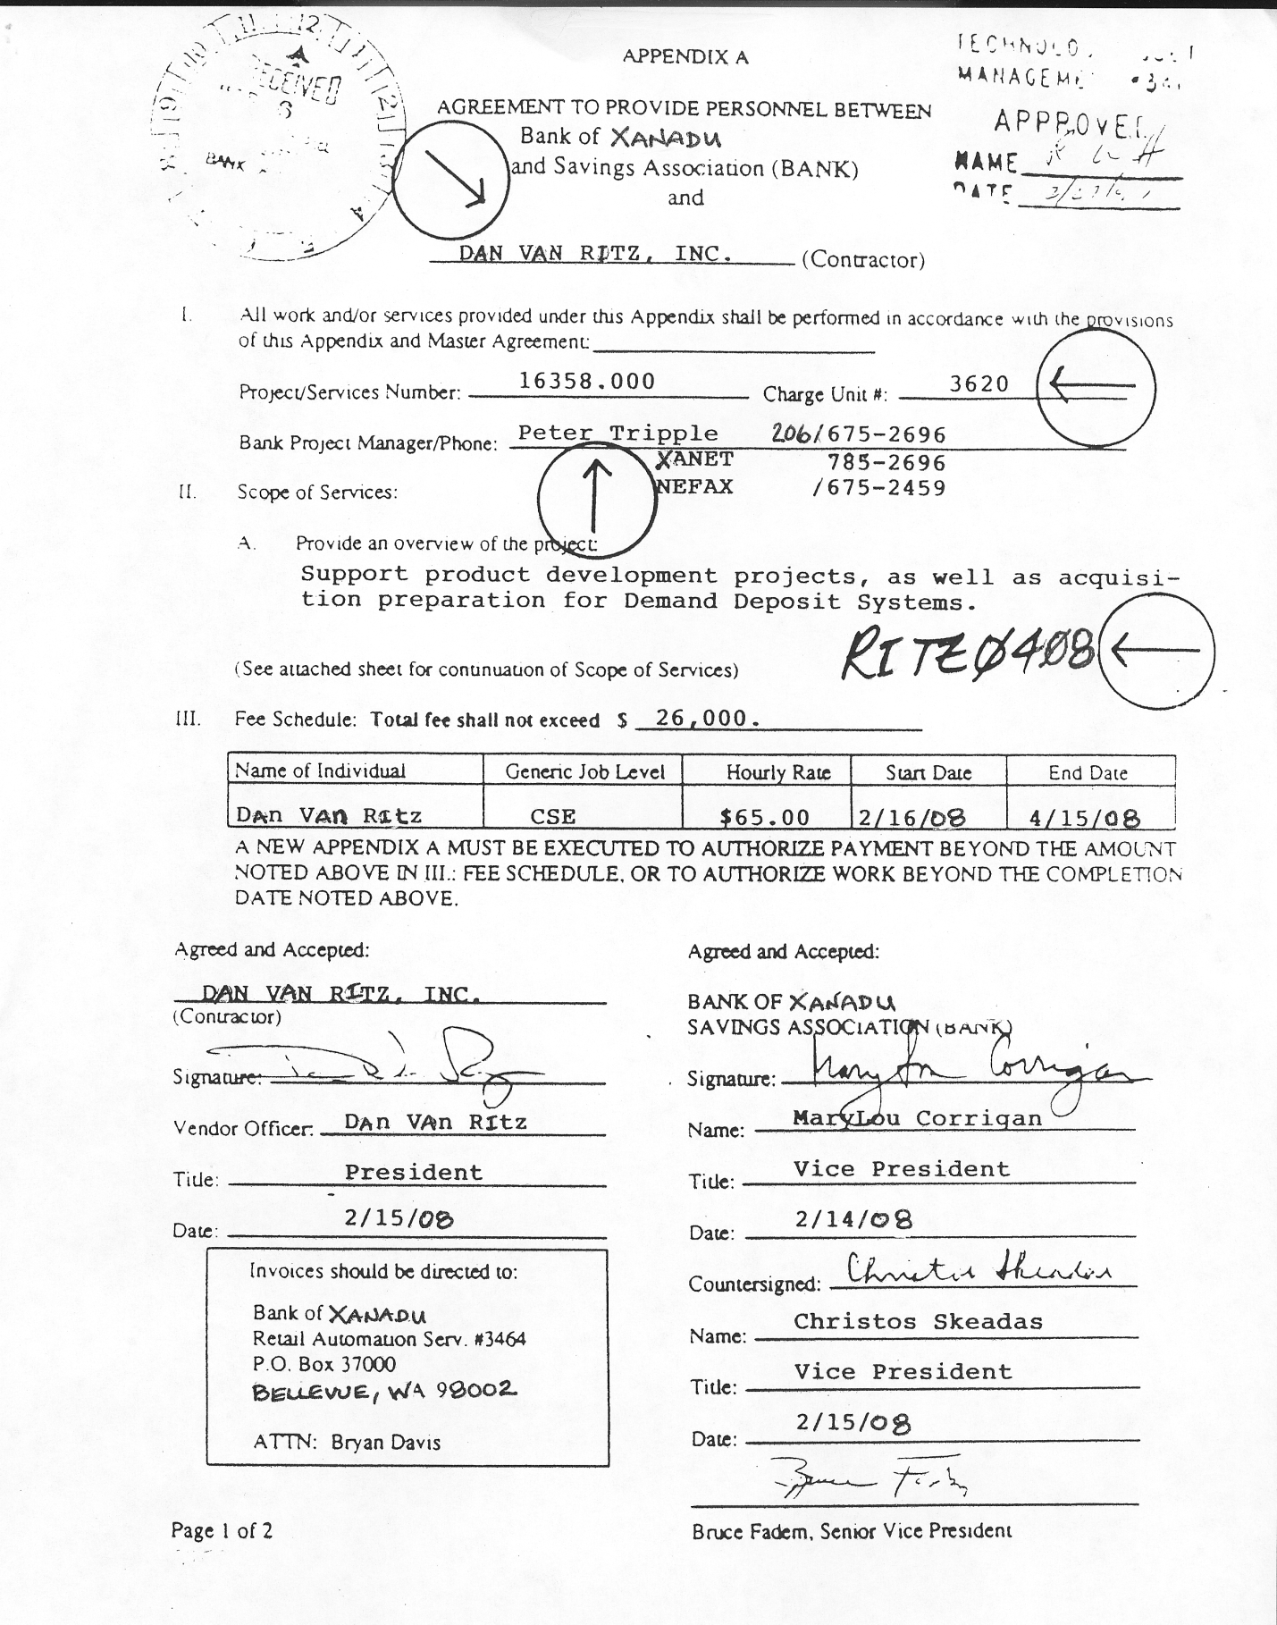

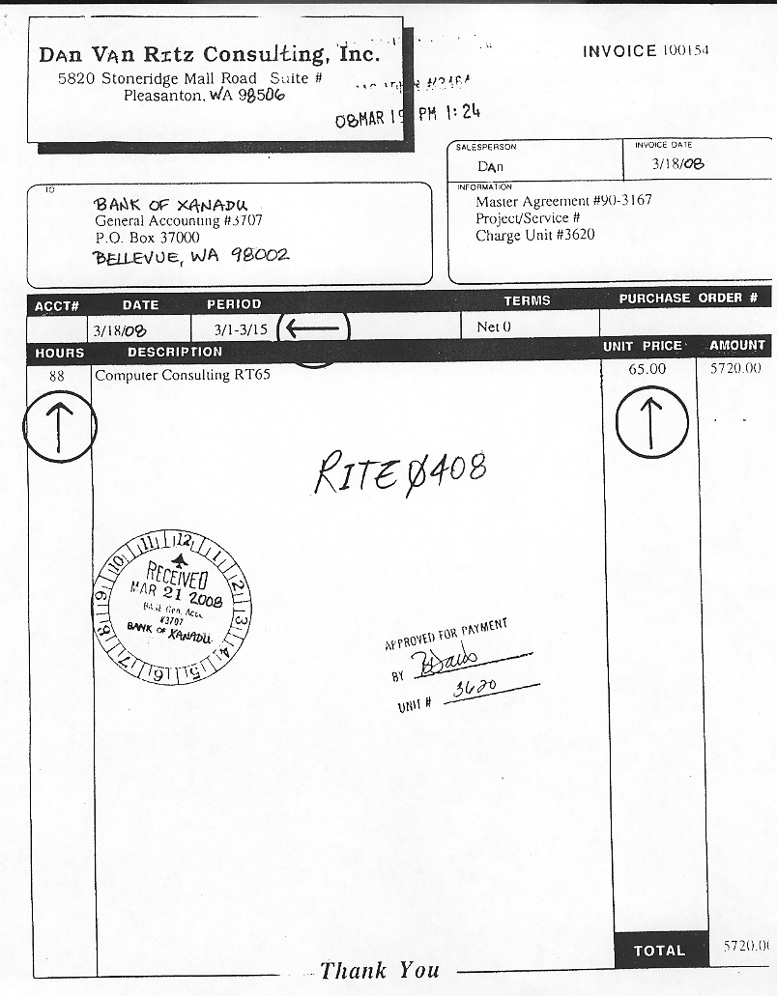
Output: Reports formats or Output documents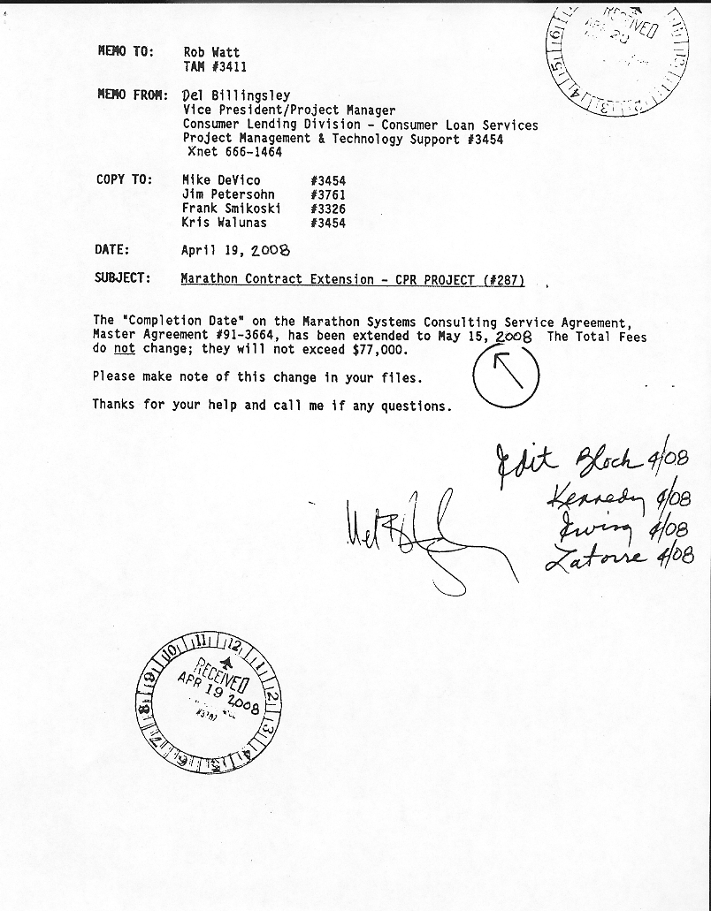
Use Cases: Diagram

Use Case Documentation

RECEIVE CONTRACT
Use Case Name: | RECEIVE CONTRACT | ID: UC001
Primary Actor: | Accountant
Brief Description: | This use case describes the steps for processing a new contract, from the time that it is delivered by the buyer, until a new contract is verified and entered into the system.
Trigger: | New contract is delivered to the accounting department
Related Use Cases: | Contract Exception (extended by); Add New Contract Information (extended by); Update Contract (used by)
Normal flow of events: | This use case begins when the Buyer delivers a new contract to the Accountant.  1) Manually review contract to ensure that all the information needed by the accounting department is on the contract.  2) Log onto the system and navigate to the "Enter Contract" screen.  3) Search for the correct Vendor (Contractor) Number and select it.  4) Enter all the required contract information (see Information Requirements below) into the system. Use appropriate " lookups" when applicable.  5) When finished entering all required information, SAVE the new contract record into the system.  This use case ends when the new contract is entered into the system.
Exception(s): | 1) If any required information is missing or invalid, an exception memo is created and sent to the buyer for resolution.  3) If the vendor is not listed, navigate to the "Create Vendor" screen and create a new vendor record.  4) If the contact (project manager), charge unit, or bank division is not listed in the appropriate lookup fields, a new record for that information will need to be created.
Pre-condition(s): | The existance of a new contract deliverd from the contract group
Post-conditions(s) | The verified contract has been entered into the system and is ready to have valid invoices processed against it.
Information Requirements: | Contract ID  Programmer  Vendor  Begin Date  End Date  Charge Unit  Bank Division  Hourly Fee  Fee Maximum  Project Manager  PM contact unit  PM phone number  Project Description
Assumptions: | The accountant must refer to the corporate directory to verify the correct contact unit for the project manager.
Business Rules: | 1) A contract is not considered valid if any of the required information is missing, and must be returned to the buyer for correction.  2) A contract can be for more than one programmer working for the same vendor.  3) A programmer may be working on more that one contract at a time  4) If the PM is not listed in the corporate directory the signing authority needs to be contacted to obtain that information.

Add New Contract
Use Case Name: | ADD NEW BANK INFORMATION | ID: UC002
Primary Actor: | Accountant
Brief Description: | This use case describes the steps for creating a new vendor, bank contact, bank unit, or bank division record, from the time a contract is received with any of these new pieces of information, until a new record(s) is entered into the system.
Trigger: | A contract is delivered to the accounting department with new vendor, contact, unit, or division information.
Related Use Cases: | Receive Contract (extends)
Normal flow of events: | This use case begins when the Buyer delivers a contract with new vendor, contact, unit, or division information to the Accountant.  1) Search for the correct Vendor (Contractor) Number and cannot find one.  2) Navigate to the "Create Vendor" screen.  3) Enter the required vendor name into the system.  4) Search for the correct Contact Person and cannot find one.  5) Navigate the the "Create Contact" screen.  6) Enter the required bank contact name into the system.  7) Search for the correct Charge Unit and cannot find one.  8) Navigate to the "Create Unit" screen.  9) Enter the required bank unit number into the system  10) Search for the correct Bank Division and cannot find one.  11) Navigate to the "Create Division" screen.  12) Enter the required bank division name into the system.  13) When finished entering any of the required information above, SAVE the new record into the system.  This use case ends when the new vendor, contact, unit, or division record is entered into the system.
Exception(s): | None.
Pre-condition(s): | The existance of a contract with new vendor, contact, unit, or division information.
Post-conditions(s) | The new vendor, contact, unit, or division information has been entered into the system..
Information Requirements: | Vendor Name  Contact Person (Project Manager)  Charge Unit  Bank Division
Assumptions: | The accountant must refer to the corporate directory to verify the correct contact unit for the project manager.
Business Rules: | 1) In order to create a new contract record, valid vendor, contact, unit, and division information must be obtained and exist in the new system.

CONTRACT EXCEPTION
Use Case Name: | CONTRACT EXCEPTION | ID: UC003
Primary Actor: | Accountant
Brief Description: | This use case describes the steps for processing a contract exception memo to return an incomplete/invalid contract to the Buyer, from the time the incomplete/invalid contract is received until it has been returned to the Buyer.
Trigger: | An incomplete or invalid contract is received from the Buyer
Related Use Cases: | Receive Contract (extends)
Normal flow of events: | This use case begins when the Buyer delivers a contract to the Accountant that is either incomplete or contains invalid information.  1) A manual review of the contract determines that one of the required pieces of information required to enter a contract into the system is missing or invalid.  2) Enter the contract into the system with as much information as possible.  3) Enter "missing/invalid" or default to "zero" value in the field for the piece(s) of information that is missing or invalid  4) Enter the date and reason for the contract return in the "Contract Notes" field  5) SAVE the contract record into the system  6) Generate a return memo to the Buyer explaining the reason for the return  7) Attach the return memo to the contract and send it back to the Buyer  This use case ends when the incomplete/invalid contract has been returned to the Buyer.
Exception(s): | None
Precondition(s): | A contract has been received that has missing or invalid information.
Postconditions(s) | The incomplete or invalid contract has been returned to the Buyer
Information Requirements: | (See "Receive Contract" use case UC001)  Contract Notes
Assumptions: | The Buyer will be able to supply the missing information or correct the invalid information
Business Rules: | 1) A contract is not considered valid if any of the required information is missing and must be returned to the Buyer for correction  2) It is the Buyer's responsibility to correct any errors in the contract and return it to the Accountant who sent it back.

UPDATE CONTRACT
Use Case Name: | UPDATE CONTRACT | ID: UC004
Primary Actor: | Accountant
Brief Description: | This use case describes the steps for updating a contract, from the time that it is delivered by the Buyer, until the updated contract information has been entered into the system.
Trigger: | An updated or revised contract is received from the Buyer
Related Use Cases: | Receive Contract (uses); Update Invoice (extends)
Normal flow of events: | This use case begins when the Buyer delivers a corrected or updated contract to the Accountant.  1) Manually review the contract to ensure all the information needed by the accounting department is on the contract  2) Search for the contract in the system  3) Change the fields that have new or revised values OR missing or zero values by entering the correct information from the updated contract  4) Enter the date returned and any additional information in the "Contract Notes" field  4) SAVE the updated contract record into the system  This use case ends when the contract has been correctly and completely updated in the system.
Exception(s): | None
Precondition(s): | An updated contract has been received from the Buyer
Postconditions(s) | A complete and valid contract has been updated in the system
Information Requirements: | (see Receive Contract - UC001)
Assumptions: | The system will be able to accept the updated contract information
Business Rules: | The accountant must enter the updated contract information into the system and make a note of the date that the updated contract was returned by the Buyer

RECEIVE INVOICE
Use Case Name: | RECEIVE INVOICE | ID: UC005
Primary Actor: | Accountant
Brief Description: | This use case describes the steps for processing a new invoice, from the time that it is received from the Programmer/Vendor, until the invoice has been entered into the system and approved for payment.
Trigger: | An invoice for programming services is received from a Programmer/Vendor
Related Use Cases: | Invoice Exception (extended by), Update Invoice (used by)
Normal flow of events: | This use case begins when a new invoice is received for programming services.  1) Manually review the invoice to ensure that all the information needed by the accounting department is on the invoice (including an authorized time sheet)  2) Log onto the system and navigate to the "Enter Invoice" screen  3) Search for the correct Vendor (Contractor) number and select it  4) Search for the correct Contract ID and select it  5) Enter all the required invoice information (see Information Requirements below) into the system. Use appropriate "lookups" when applicable.  6) Run a system check to ensure that the dates for programming services fall within the date range specified on the contract  7) Run a system check to ensure that the billed rate is the same as the "Hourly Fee" on the contract  8) Run a system check to ensure that the dollar amount of the invoice does not exceeded the "Fee Maximum" amount on the contract (must consider all previous invoices that have been paid against the contract fee maximum)  9) When finished entering all required information and validating that the invoice services fall between the valid contract dates, AND the billed rate matches the contract, AND the total dollar amount of the invoice has not exceeded the contract fee maximum, select "Approved to Pay" as the Payment Status.  10)SAVE the invoice record into the system  This use case ends when the invoice is entered into the system with an "Approved to Pay" status.
Exception(s): | 1) If any necessary information is missing from the invoice (including the time sheet), an exception memo is created and sent with the invoice to the Buyer for resolution.  3) If the Vendor is not listed (may indicate no valid contract), an exception memo is created and sent with the invoice to the Buyer for resolution (see next exception).  4) If the "Contract ID" cannot be located in the system (but there is a valid Vendor), an exception memo is created and sent with the invoice to the Buyer for resolution.  5) If the dates of service is outside those specified on the contract, an exception memo is created and sent with the invoice to the Buyer for resolution.  6) If the billed hourly rate for services does not match that specified on the contract, an exception memo is created and sent with the invoice to the Buyer for resolution.  7) If the total dollar amount of the invoice causes the maximum contract fee to be exceeded, an exception memo is created and sent with the invoice to the Buyer.
Precondition(s): | An invoice has been received for contract programming services
Postconditions(s) | The invoice has been verified for payment and entered into the system
Information Requirements: | Vendor  Remit-to Address  Contract ID  Invoice Number  Invoice Date  Programmer  Service Start Date  Service End Date  Hourly Rate  Total Hours Worked  Invoice Total  Invoice Terms  Approved By  Charge Unit  Payment Status
Assumptions: | 1) A valid contract has already been entered into the system for the services specified on the invoice and the invoice is payable against that contract.  2) If the Vendor is not in the system, then there would also not be a valid contract either.  3) The Vendor will not send an invoice for programming services without first signing a contract with the Bank  4) The Vendor will not send an invalid or incorrect invoice that violated the terms of the contract.  5) The proper invoice approval process has been followed by the Project Manager.
Business Rules: | 1) To be considered a valid invoice, it must contain all the information required by both the Buyer and Accounting department (including both signed and approved invoice and time sheet(s).  2) The Bank must not authorize programming services without first executing a valid contract for such services.  3) The project manager is responsible for verifying that the information on the invoice is correct and that a valid time sheet has been included with the invoice.  4) The project manager must approve the invoice and sign-off authorizing payment, including the proper bank unit that is to be charged.  5) An invoice cannot be paid if it exceeds the terms of the contract, including the dates of service and hourly rate.  6) Payment of invoice does not exceed the contractual fee maximum amount after all the previous invoice totals have been tallied and deducted from the fee maximum.

INVOICE EXCEPTION
Use Case Name: | INVOICE EXCEPTION | ID: UC006
Primary Actor: | Accountant
Brief Description: | This use case describes the steps for processing an invoice exception memo to return an incomplete, invalid, or unpayable invoide to the Buyer, from the time the incomplete, invalid, or unpayable invoice is received until it has been returned to the Buyer.
Trigger: | An incomplete, invalid, or unpayable invoice is received from the Vendor
Related Use Cases: | Receive Invoice (extends)
Normal flow of events: | This use case begins when the Vendor sends an invoice for programming services to the Accountant (should arrive via the Project Manager).  1) A manual review of the invoice determines that one of the required pieces of information required to enter the invoice into the system for payment is missing (see Information Requirements below), OR, in the process of running a system check, it is determined that the invoice dates of service exceed those on the contract, or the "Hourly Fee" does not match with that of the contract, or payment of the invoice would cause the "Fee Maximum" amount of the contract to be exceeded  2) Enter the invoice into the system with as much information as possible  3) Enter "missing/invalid" or default to "zero" value in the field for the piece(s) of information that is missing or invalid  3) Enter the "Payment Status" as "Do Not Pay"  4) Enter into the "Invoice Notes" field the reason the invoice cannot be paid  5) SAVE the invoice into the system  6) Generate a return memo to the Buyer explaining the reason for the return  7) Attach the return memo to the invoice and send it back to the Buyer  This use case ends when the invomplete, invalid, or unpayable invoice has been returned to the Buyer.
Exception(s): | None
Precondition(s): | An invoice has been received that is either incomplete, invalid, or otherwise unpayable.
Postconditions(s) | The incomplete, invalid, or otherwise unpayable invoice has been returned to the Buyer.
Information Requirements: | (See Receive Invoice UC005)  Payment Status  Invoice Notes
Assumptions: | 1) The Buyer will be able to contact the Vendor and get a corrected invoice generated  2) The Buyer will be able to contact the Program Manager to get proper approval and charge information  3) The Buyer will be able to contact the appropriate parties and get a contract extension for either additional time period(s), and/or an adjustment to the "Hourly Fee", and/or an increase in the "Maximum Fee" amount
Business Rules: | 1) An invoice is not considered payable if any of the required information is missing and must be returned to the Buyer for resolution  2) It is the Buyer's responsibility to contact the Vendor to get a corrected invoice resent to the Bank that is able to be processed for payment  3) It is the Buyer's responsibility to contact the Project Manager if the invoice does not have the proper approval for payment  4) It is the Buyer's responsibility to contact the appropriate parties and generate a contract extension if the invoice service dates fall outside those of the original contact, OR the "Hourly Fee" does not match with that of the original contract, OR payment of the invoice would cause the "Fee Maximum" amount on the original contract to be exceeded

UPDATE INVOICE
Use Case Name: | UPDATE INVOICE | ID: UC007
Primary Actor: | Accountant
Brief Description: | This use case describes the steps for updating an invoice, from the time that a revised or new invoice and/or contract extension is received from the Buyer, until the updated or new invoice and/or contract extension has been entered into the system.
Trigger: | An updated or new invoice and/or a contract extension is received from the Buyer
Related Use Cases: | Receive Invoice (uses); Update Contract (extended by)
Normal flow of events: | This use case begins when the Buyer delivers an updated or new invoice and/or a contract extension to the Accountant.  1) Manually review the invoice to ensure all the information needed by the accounting department is on the invoice  2) If a contract extension is received, manually review it to ensure that all the information needed by the accounting department is on the contract extension  3) If a contract extension is received, search for the original contract in the system  4) Enter the new contract information in the system (see Information Requirements below and refer to UC004 for normal flow of events) (if applicable)  5) SAVE the updated contract record into the system (if applicable)  6) Search for the returned invoice in the system  7) Change the fields that have missing or zero values by entering the correct information from the updated or new invoice  8) Run a system check to ensure that the dates for programming services fall within the date range specified on the revised contract  6) Run a system check to ensure that the billed rate is the same as the "Hourly Fee" on the revised contract  7) Run a system check to ensure that the dollar amount of the revised or new invoice does not exceeded the "Fee Maximum" amount on the updated contract (must consider all previous invoices that have been paid against the contract fee maximum)  8) When finished entering all required information and validating that the revised or new invoice is able to be paid, change the "Payment Status" from "Do Not Pay" to "Approved for Payment"  9) Enter into the "Invoice Notes" field the date the invoice was returned  10) SAVE the invoice record into the system  This use case ends when the revised or new invoice and/or contract extension has been correctly and completely updated in the system.
Exception(s): | 7) If the invoice number has been changed (Vendor issued a newly numbered invoice), the old number must first be noted in the "Invoice Notes" field BEFORE overwriting the "Invoice Number" field (actually, the vendor should issue a credit memo for the original invoice that would be entered into the system to offset the original invoice, necessitating a new record for the new numbered invoice)  8) If the invoice still fails any of the system checks, follow the procedures under use case UC006 (Invoice Exception) to return the invoice back to the Buyer
Precondition(s): | 1) A revised invoice has been received from the Buyer  2) A contract extension has been received from the Buyer
Postconditions(s) | 1) The updated or new invoice has been entered into the system with the "Approved to Pay" status  2) The contract extension information has been entered into the system and the contract has been updated
Information Requirements: | (UC001)  Begin Date  End Date  Hourly Fee  Fee Maximum  (see UC005 "Receive Invoice" for applicable data)  Payment Status  Invoice Notes
Assumptions: | 1) The Buyer will have taken the necessary steps to ensure the new information provided on the invoice and/or contract extension is sufficient to allow the invoice to be payable  2) If the vendor changes the invoice number, they will either issue a credit memo to cancel the previous unpayable invoice OR they will somehow notify the Accounting department (Accountant) with instructions to modify/change the previous invoice number and ignore the fact that it existed
Business Rules: | 1) The Accountant must enter the updated invoice and/or contract information into the system and make a note of the date that the updated contract and/or invoice was returned by the Buyer.  2) If the invoice number needs to be changed, the Accountant must document fully the circumstances surrounding the change and/or document that a credit memo was received to offset the original invoice.  3) The Accountant must re-check the updated invoice against the contract limitations before approving it for payment

Invoice Status Inquiry
Use Case Name: | INVOICE STATUS INQUIRY | ID: UC008
Primary Actor: | Accountant
Brief Description: | This use case describes the steps for responding to a Vendor inquiry for invoice payment status, from the time the inquiry is received by the Accountant until the Accountant has responded to the Vendor with the requested invoice payment status.
Trigger: | The Accountant receives an inquiry from the Vendor for payment status on an invoice
Related Use Cases: | None
Normal flow of events: | This use case begins when the Accountant receives an invoice payment status inquiry from the Vendor.  1) Log onto the system and search for the invoice in question (run a report or query)  2) Check the "Payment Status" field to determine the current status  3) If the invoice has a "Do Not Pay" status, check the "Invoice Notes" field to determine the reason the invoice cannot be currently processed for payment  4) If the Vendor is on the telephone, convey the details of the invoice payment status to the Vendor  5) If the invoice is not currently payable, explain the reason(s) for non-payment  6) If the Vendor has communicated via email, send an email through the system to the Vendor providing the invoice payment status or reason(s) for non-payment  7) Enter into the "Invoice Notes" field the date of the Vendor inquiry and the response that was provided in reply  8) SAVE the updated invoice record into the system  This use case ends when the Vendor has received the invoice payment status.
Exception(s): | 1) If the invoice has not been received and entered into the system, instruct the Vendor to resend or fax (preferred) a copy of the invoice in question directly to the Accounting department (Accountant), and then proceed with the steps to "Receive Invoice" (see UC005) and process an "Invoice Exception" (see UC006)  (6 &7) If the vendor has sent either a payment request letter or a duplicate copy of the original invoice, check the status of the invoice in question and either call (preferred) the Vendor or send them a letter through the US Postal Service
Precondition(s): | The Vendor has sent an invoice for programming services and has not received payment according to the terms of the invoice
Postconditions(s) | 1) The Vendor has been updated on the current payment status of the invoice  2) If applicable, a copy of the invoice (see #1 under Precondition(s) has been sent with an exception memo to the Buyer for resolution
Information Requirements: | Vendor  Invoice Number  Contract ID  Payment Status  Invoice Notes
Assumptions: | 1) The Vendor will not send an invoice for programming services before a valid contract has been created for those services  2) The invoice in question will have been received by the Accounting department (Accountant) and entered into the system prior to the actual due date of the invoice  3) The Accountant will be able to satisfy the Vendor's inquiry with the information contained in and available in the system
Business Rules: | 1) An invoice is not payable unless a valid contract exists for the services billed on the invoice, and the invoice meets the constraints of that contract  2) Vendor inquiries must be resolved within a 24 hour timeframe  3) If a Vendor inquires about an invoice that is not currently in the Accounting system, the Accountant must request a copy of that invoice so it can be entered into the system and then sent to the Buyer for resolution

PAY INVOICE
Use Case Name: | PAY INVOICE | ID: UC009
Primary Actor: | Accountant
Brief Description: | This use describes the steps for sending an invoice that is approved for payment to the Accounts Payable (A/P) department, from the time the Accountant has approved the invoice for payment until the invoice has been sent to the A/P department.
Trigger: | Invoice(s) are entered into the system with an "Approved to Pay" Payment Status
Related Use Cases: | None
Normal flow of events: | This use case begins when the Accountant has set the invoice Payment Status to "Approved to Pay".  1) If necessary, log onto the system and locate the invoice to be paid  2) Verify the Payment Status is "Approved to Pay"  3) Enter the current day's date in the "Date Paid" field  4) SAVE the invoice record  5) Generate and print out a Data Entry Sheet for the invoice  6) Attach the Data Entry Sheet to the Invoice and send both to the A/P department  This use case ends when the invoice has been has been updated with the "Date Paid" and sent to the A/P department to have a check issued.
Exception(s): | 3) If the "Date Paid" is AFTER the cut-off for the last A/P check run for the CURRENT month AND before the 6th day of the FOLLOWING month, the invoice will need to be accrued
Precondition(s): | An invoice is approved for payment and is ready to be sent to A/P to have a check cut.
Postconditions(s) | The invoice has been sent to the A/P department with a Data Entry Sheet attached.
Information Requirements: | Vendor Name  Vendor Number  Invoice Number  Description (the programmer's 1st initial and full last name AND the dates of service covered by the invoice)  Invoice Date  Invoice Total  G/L Account  P.O. Number (the programmer's 1st initial and full last name)  Charge Unit  Accountant's Name  Date Paid (date invoice is sent to the A/P group)
Assumptions: | All invoices received for services in the current month can be processed for payment and have a check cut by the A/P department before the end of the current month
Business Rules: | 1) All invoices sent to the A/P department for payment must include a Data Entry Sheet with specific information (see Information Requirements above)  2) If an invoice cannot have a check cut for it BEFORE the end of the current time period (month), an accural must be made so the expense dollars can be charged to the appropriate general ledger account to ensure the expense is realized in the appropriate period.

Accrue Invoice
Use Case Name: | ACCRUE INVOICE | ID: UC010
Primary Actor: | Accountant
Brief Description: | This use case describes the steps for processing an invoice accrual, from the time the invoice is determined to need to be accrued, until the invoice has been designated as accred in the system
Trigger: | The invoice has been received and entered into the system after the cut-off for the last Accounts Payable (A/P) checkrun of the current month but before the 6th day of the following month.
Related Use Cases: | Pay Invoice (extends)
Normal flow of events: | This use case begins when an invoice has been entered into the system that either cannot be processed for payment OR is payble and cannot have a check cut in the current month.  1) If necessary, log onto the system and locate the invoice that needs to be accrued  2) Verify that the date in the "Date Paid" field is past the cut-off date for the last A/P checkrun for the current month and before the 6th day of the following month OR the "Payment Status" is "Do Not Pay"  3) Enter the current month and year in the "Date Accrued" field  4) SAVE the invoice record in the system  5) Repeat the above 4 steps for ALL invoices that meet the criteria for accrual  This use case ends when an invoice has been designated as accrued in the system.
Exception(s): | None
Precondition(s): | 1) An invoice has been received and entered into the system with either a "Do Not Pay" status OR  2) An invoice has been processed for payment after the cut-off date for the last A/P checkrun for the current month and before the 6th day of the following month
Postconditions(s) | The unpaid (no check cut) invoice has been designated as accrued
Information Requirements: | Programmer  Vendor  Charge Unit  Invoice Number  Invoice Total  Date Accrued (month and year)
Assumptions: | All invoices for services in the current time period will have been received by the 6th day of the following time period
Business Rules: | Any invoice that cannot have a check issued for it in the current time period (month) must be accrued so that the expense can be realized in the current period.

Run Accounting Invoice
Use Case Name: | RUN ACCOUNTING REPORTS | ID: UC011
Primary Actor: | Accountant
Brief Description: | This use case describes the steps to generate the Accounting department's month-end reports, from the time they are due until they have been printed out and delivered to the Accounting Manager.
Trigger: | The deadline for the month-end Accounting department reports.
Related Use Cases: | None
Normal flow of events: | This use case begins when the deadline due date for the "General Ledger Expense Report" and "Accrual Report" is reached.  1) Log onto the system and navigate to the Reports Menu  2) Select the "G/L Expense" option  3) Enter the date range for the current reporting period  4) Select the PRINT REPORT option  5) Return to the Reports menu  6) Select the "Accruals" option  7) Enter the date range for the current reporting period  8) Select the PRINT REPORT option  9) Return to the Reports Menu OR exit to the Main Menu  10) Deliver both reports to the Acounting Manager  This use case ends when both the "General Ledger Expense Report" and "Accrual Report" have been delivered to the Accounting Manager.
Exception(s): | None
Precondition(s): | It is time to generate the monthly Accounting department reports
Postconditions(s) | The monthly Accounting department reports have been delivered to the Accounting Manager
Information Requirements: | (General Ledger Expense Report)  Contract ID  Programmer  Vendor  Charge Unit  Invoice Number  Date Paid  Service Start Date  Service End Date  Hourly Fee  Total Hours Worked  Invoice Total  Date Accrued  Total G/L Expense (calculated)  (Accrual Report)  Programmer  Vendor  Charge Unit  Invoice Number  Invoice Total  Date Accrued  Total Accrued (calculated)
Assumptions: | There will actually be at least one invoice to be accrued for the current reporting period
Business Rules: | The "General Ledger Expense Report" and "Accrual Report" are due to the Accounting Manager for auditing purposes on the 6th business day of the month.

Run Management Reports
Use Case Name: | RUN MANAGEMENT REPORTS | ID: UC012
Primary Actor: | Accountant
Brief Description: | This use case describes the steps to generate Bank Management's month-end reports, from the time they are due until they have been printed out and sent to the various requesting departments.
Trigger: | The deadline for the month-end Bank Management reports.
Related Use Cases: | None
Normal flow of events: | This use case begins when the deadline due date for the "Contract Programmer's Monthly Expense Recap Report", "Contract Programmer Report - Fee Maximum vs. Actuals", and "Monthly Contract Recap" is reached.  1) Log onto the system and navigate to the Reports Menu  2) Select the "Programmer Expense" option  3) Enter the date range for the current reporting period  4) Select the PRINT REPORT option  5) Return to the Reports menu  6) Select the "Fee Maximum" option  7) Enter the date range for the current reporting period  8) Select the PRINT REPORT option  9) Return to the Reports Menu  10) Select the "Contract Recap" option  11) Enter the date range for the current reporting period  12) Select the PRINT REPORT option  13) Return to the Reports Menu OR exit to the Main Menu  14) Send a copy of each report to the appropriate bank requesting unit  This use case ends when the "Contract Programmer's Monthly Expense Recap Report", "Contract Programmer Report - Fee Maximum vs. Actuals", and "Monthly Contract Recap" have been sent to the appropriate bank requesting unit(s).
Exception(s): | None
Precondition(s): | It is time to generate the monthly Bank Management reports.
Postconditions(s) | The monthly Bank Management reports have been sent to the various bank units.
Information Requirements: | (Contract Programmer's Monthly Expense Recap Report)  Programmer  Vendor  Bank Division  Charge Unit  Invoice Number  Service Start Date  Service End Date  Total Hours Worked  Invoice Total  Date Accrued  Total for Division (calculated)  Total for Charge Unit (calculated)  Grand Total (calculated)  (Contract Programmer Report - fee Maximum vs. Actuals)  Division  Charge Unit  Programmer  Service Start Date  Service End Date  Hourly Rate  Project Manager  PM Phone Number  Fee Maximum  Total Charged to Contract (calculated)  Percent Used (calculated)  Date Last Charged (calculated)  Under/Over Contract Fee Max (calculated)  (Monthly Contract Recap)  Project Manager  PM Contact Unit  Programmer  Vendor  Begin Date (contract)  End Date (contract)  Hourly Fee  Project Description  Fee Maximum  Charge Unit  Invoice Number  Date Paid  Service Start Date  Service End Date  Total Hours Worked  Invoice Total  Total Charged to Contract (calculated)  Percent Used (calculated)  Remaining Contract Dollars (calculated)
Assumptions: | There will actually be at least one invoice paid to the contract programmer G/L account 507613 in the current reporting period
Business Rules: | The "Contract Programmer's Monthly Expense Recap Report", "Contract Programmer Report - Fee Maximum vs. Actuals", and "Monthly Contract Recap" are due to be sent to the various bank requesting units by the 11th business day of the month.

Internal Procedures:

EmployeeWeeklyStatus
SELECT tblEmployee.FirstName, tblEmployee.LastName, tblProject.ProjectName, tblProject.Phase, tblTask.TaskName, tblStatusReport.ReportDate,

TeamProjectManagerWeeklyStatus
SELECT tblRole.Title, tblEmployee.FirstName, tblEmployee.LastName, tblProject.ProjectName, tblProject.Description, tblProject.Status, tblProject.Phase, tblContract.StartDate, tblContract.EndDate

TeamEmployeeWeeklyStatus
SELECT tblEmployee.FirstName, tblEmployee.LastName, tblTask.TaskName, tblTask.Phase, tblTaskAssignment.StartDate, tblTaskAssignment.EndDate, tblTaskAssignment.Status, tblStatusReport.Hours, tblProject.ProjectName

CorporateSummary
SELECT tblLocation.City, tblProject.ProjectName, tblProject.Phase, tblProject.Description, tblContract.StartDate, tblContract.EndDate, tblProject.Status, tblStatusReport.Hours

Design Standards Document:

Introductory Screen
Font and size
- Verdana, 18 points
Image

Main Menu
Font and size
- Verdana, 18 points
- 16 points for links
Title

Program Links

Sub Menus
Font and size
- Verdana, 18 points
- 16 points for links
Titles
- Projects
- Reports
Program Links

Data Entry Screens
Font
- Title -
- Labels and Buttons -
- Data Entry Fields -
- 20 point for title
- 18 point for labels and buttons
- 16 point for data entry fields
Titles
- Create a new project
- Customer Information
- Update Project Information
- Assign project Roles
- Team member project Assignment
- Project Task Assignment
- Weekly Status Information
Buttons
- Middle location
- 2 Height ******
- 3 Width *****
- Labels – utilize were appropriate
- Save
- Return to main menu
- Return to projects menu
- Save changes and return to create a new project
- Save changes and return to main menu
- Return to reports menu
- Print

Coding Standards

Guidelines for Commenting Code:
This project will be included at the beginning of every procedure to explain the overall purpose and functions of the procedure step by step. This opening comment will include the following information:
- Name of procedure
- Name of developer
- Date created
- Date modified
- Description of procedure
- Description of modification

Naming convention for Code Variables and Objects
- No spaces are allowed in variable and object names. Use underscores if spaces are required between distinguished words. For example First_Name instead of First Name).
- The prefixes for object names will be:
  - frm for forms
  - mnu for menus
  - txt for text boxes
  - lbl for labels
  - lst for list

Issue List:

Future List:
A future list contains potential ideas or requirements identified during the design that we could not be completed within the scope and time frame of this project.
1. Drop down choice lists
2. Some of the coding are not working
3.

GRADING COMMENTS:
-7 points – Inputs & Outputs sections incomplete.
-2 points – formatting, grammar, and organization issues
-2 points – conclusion, issues, meta data, and futures list issues

